**EMERCADO**

Vijaya Bhasker Reddy Singi Reddy (class id:53)

Bharat Viswanadham (class id:47)

Vijay Akkinepally (class id:1)

Vamsi Krishnam Raju TirumalaRaju (class id:38)

Existing Services will be used in Project:

1. **Farmer Market API**

This API is used to get following details:

1. Get nearby Markets using zip code.
2. Get Market details
3. Products available in market.

**Reference Link:** <http://search.ams.usda.gov/farmersmarkets/v1/svcdesc.html>

1. **Google Maps API**

This API is used to get the directions to the market, and show directions to market to users.

**Reference Link:** <https://developers.google.com/maps/documentation/javascript/tutorial>

1. **Google Chart API**

This API is used to display the sales of farmer using google charts.

**Reference Link:** <https://developers.google.com/chart/>

1. **Facebook API**

This API is used to post some updates to social networking sites.

**Reference Link:** <https://developers.facebook.com/docs/javascript>

**Sequence Diagram**

Farmer Registration:



Customer Registration



Farmer Login



Customer Login



Admin Login



Class Diagram for User, Farmer and Admin



**Design of Mobile Client Interface:**

The design of client interface is done with use of HTML, CSS, Javascript , Twitter Bootstrap, C# Asp.Net.

**Implementation:**

The Phase 1 of project implements

1. Registration page for Farmer, Customer
2. Login Page for Farmer, Customer and Admin.
3. Entry Items page for Farmer.
4. Welcome page for project.
5. Validations for all registrations and login pages.

**Project ScrumDo link :**

<https://www.scrumdo.com/organization/umkc_ase/dashboard>

**GitHub site URL:**

<https://github.com/vs8ff/E-MERCADO/>

**Screenshots**:

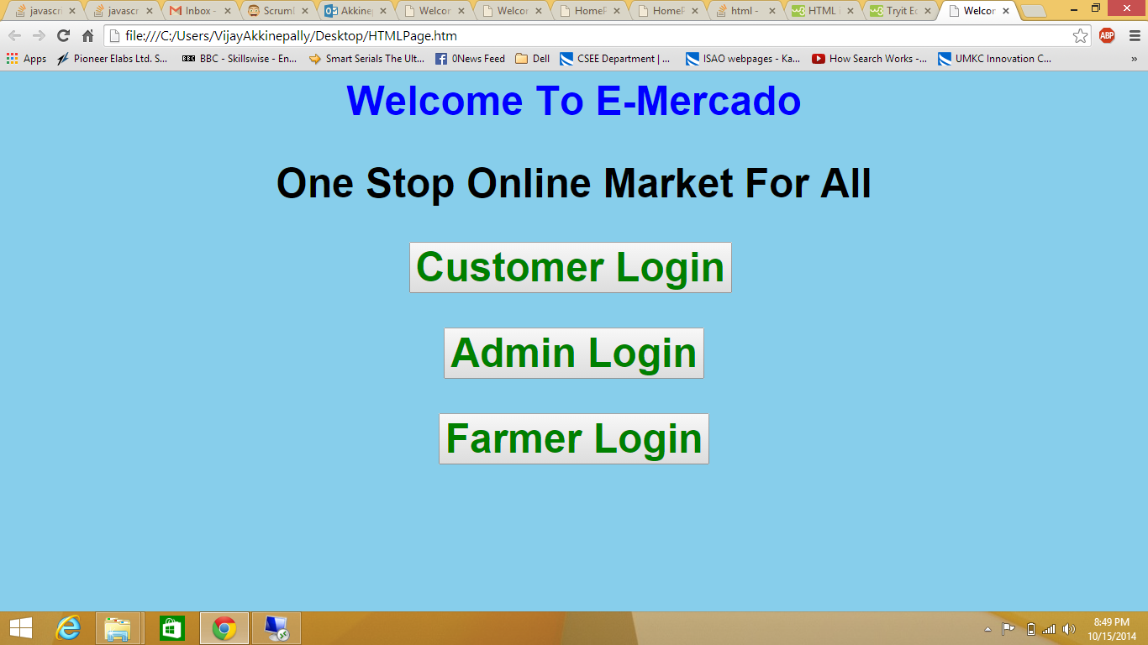

Welcome page

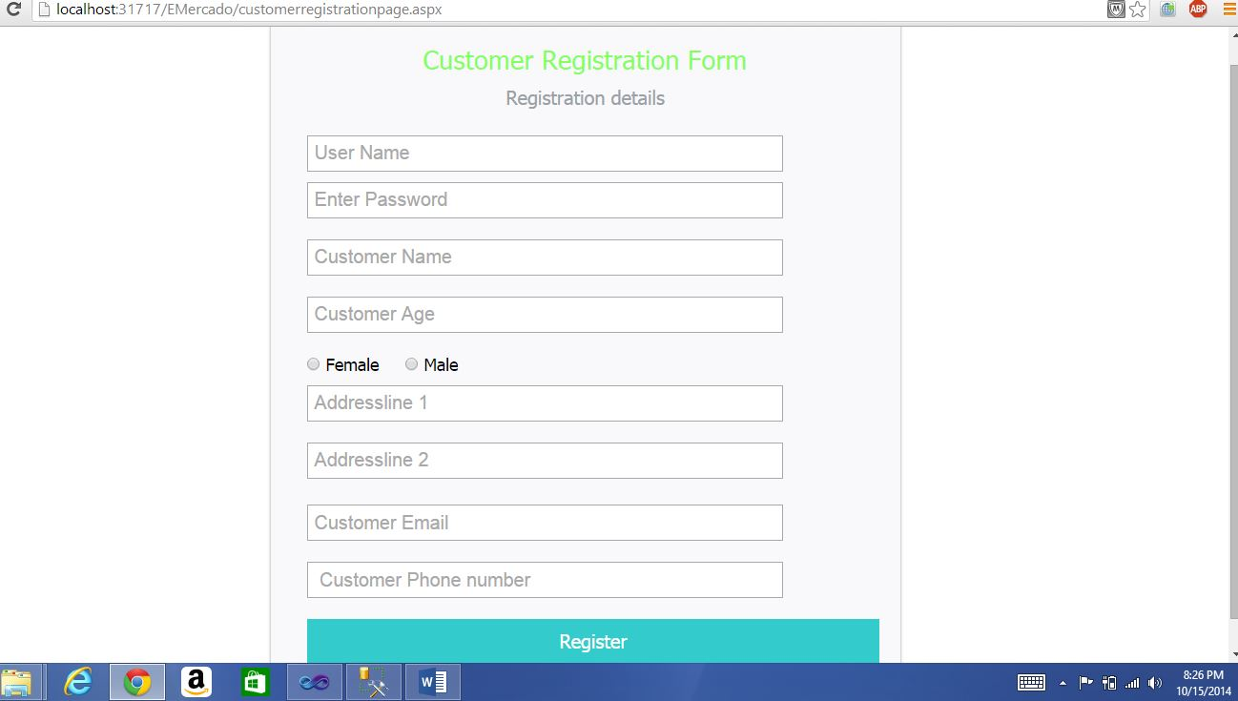

Customer Registration page

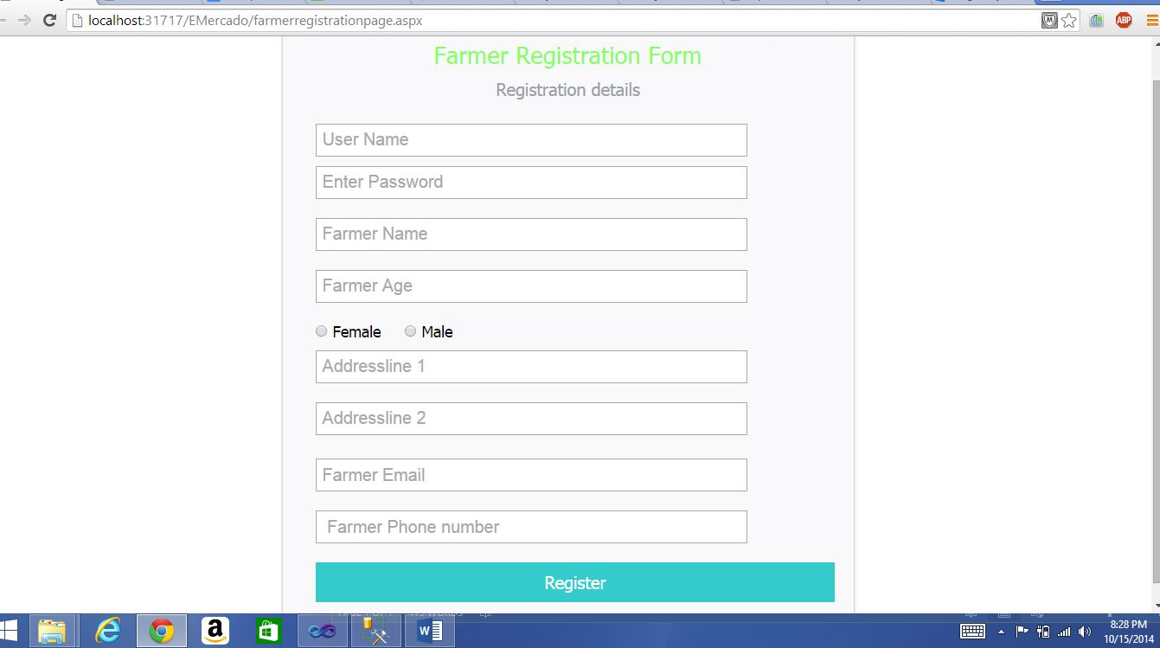

Farmer Registration page

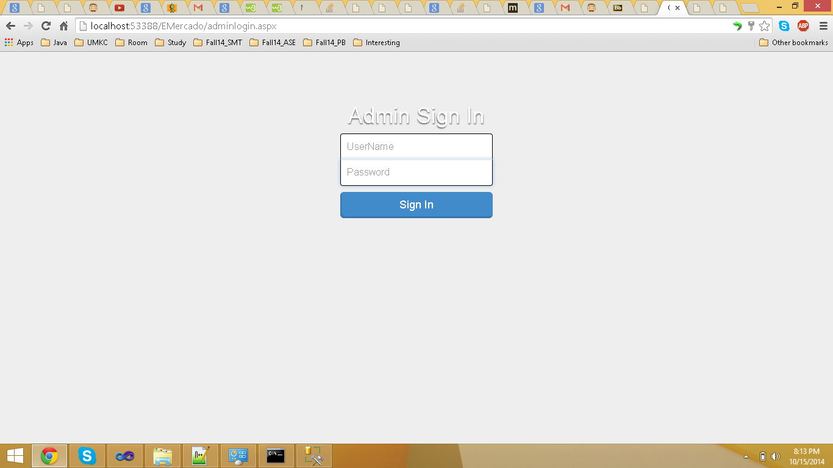

Admin Login page

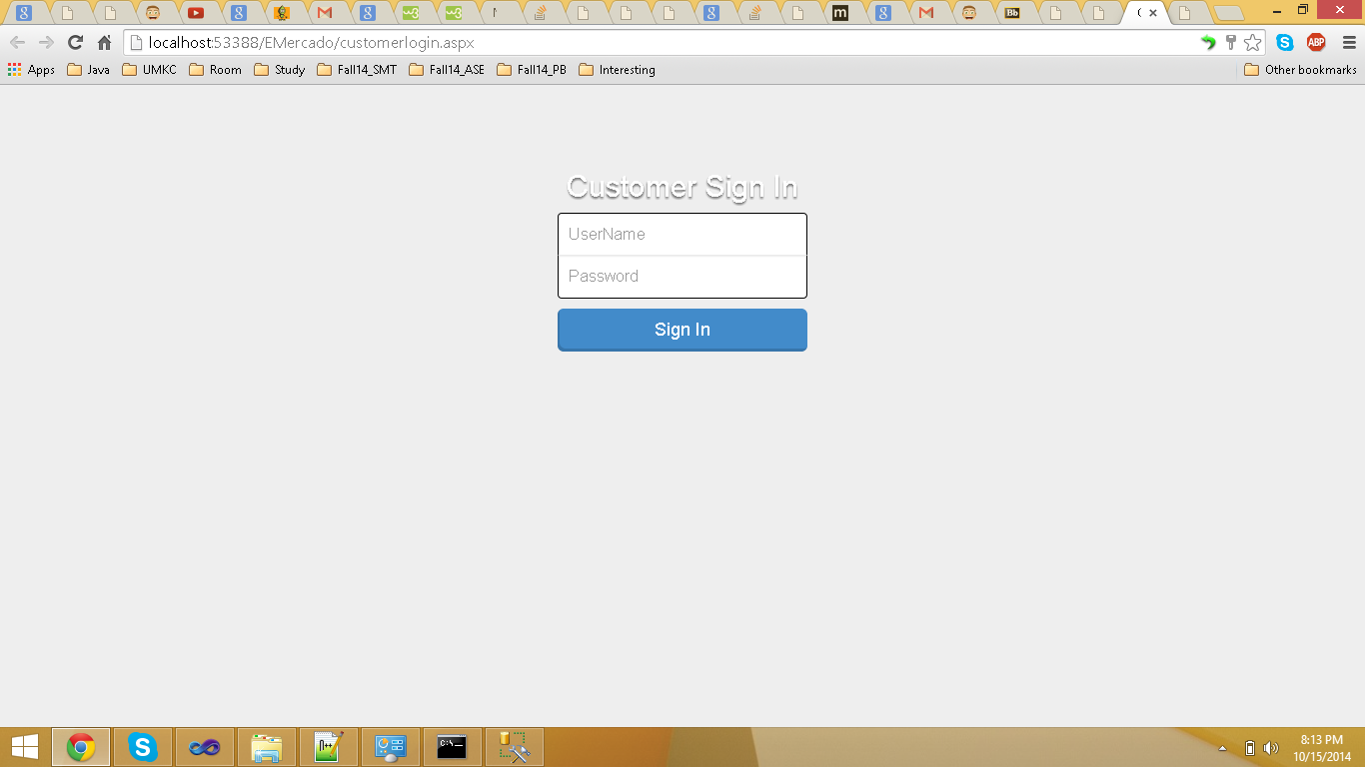

Customer Login page

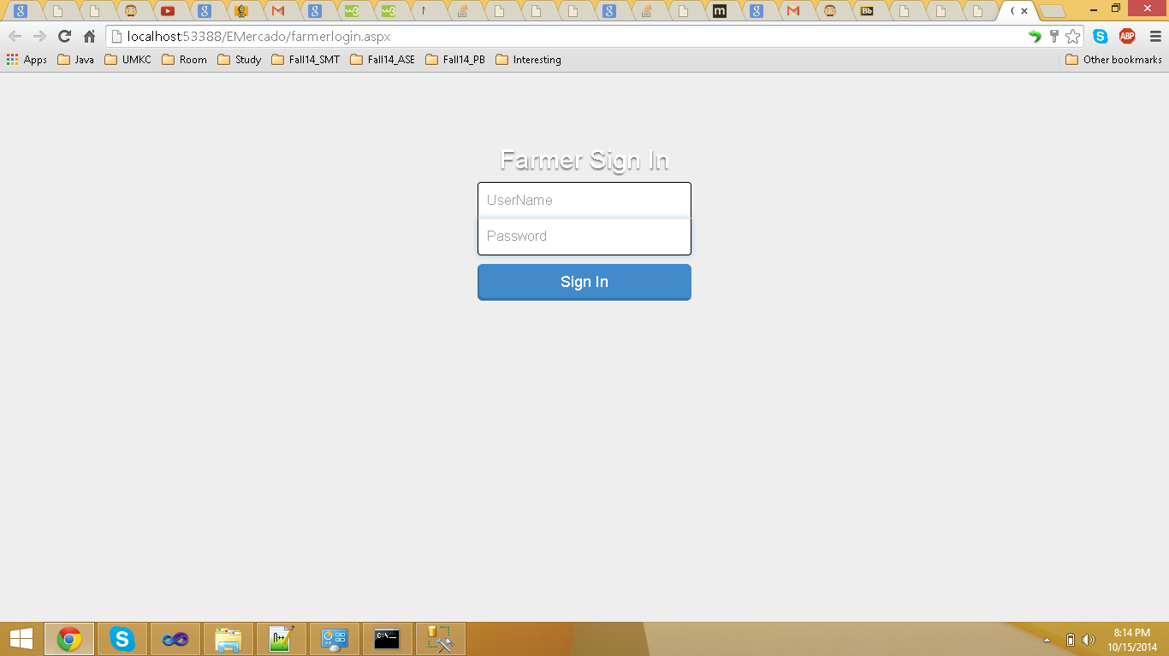

Farmer Login page

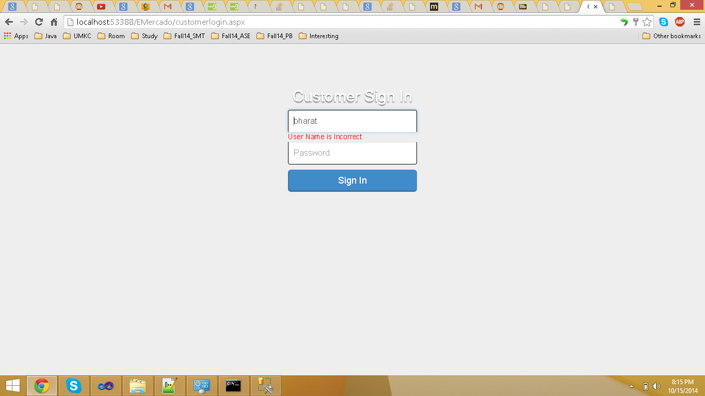

Customer Login page Validations 1

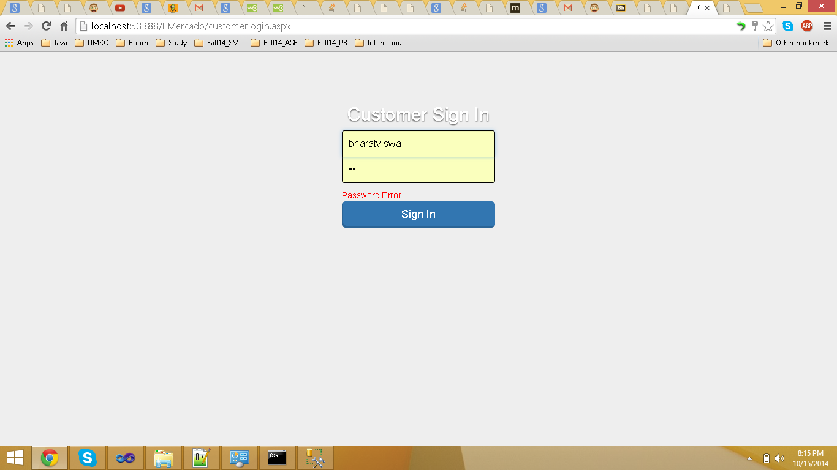

Customer Login page Validations 1

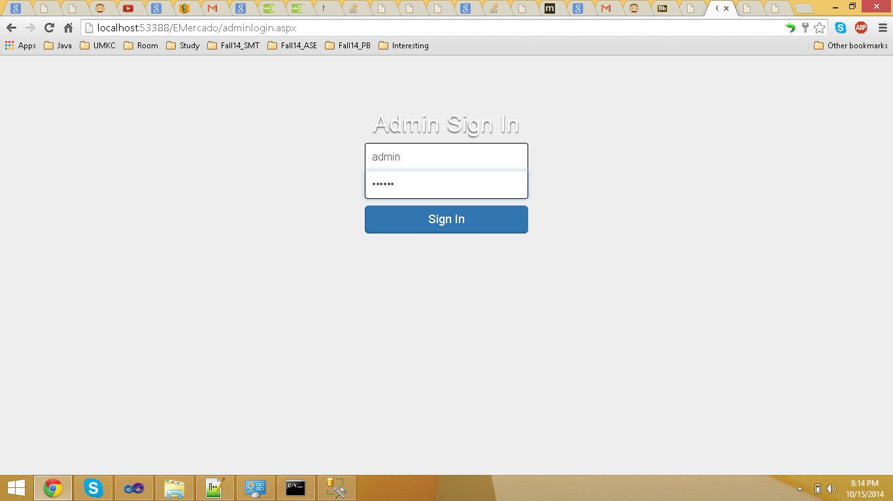

Admin Login page details

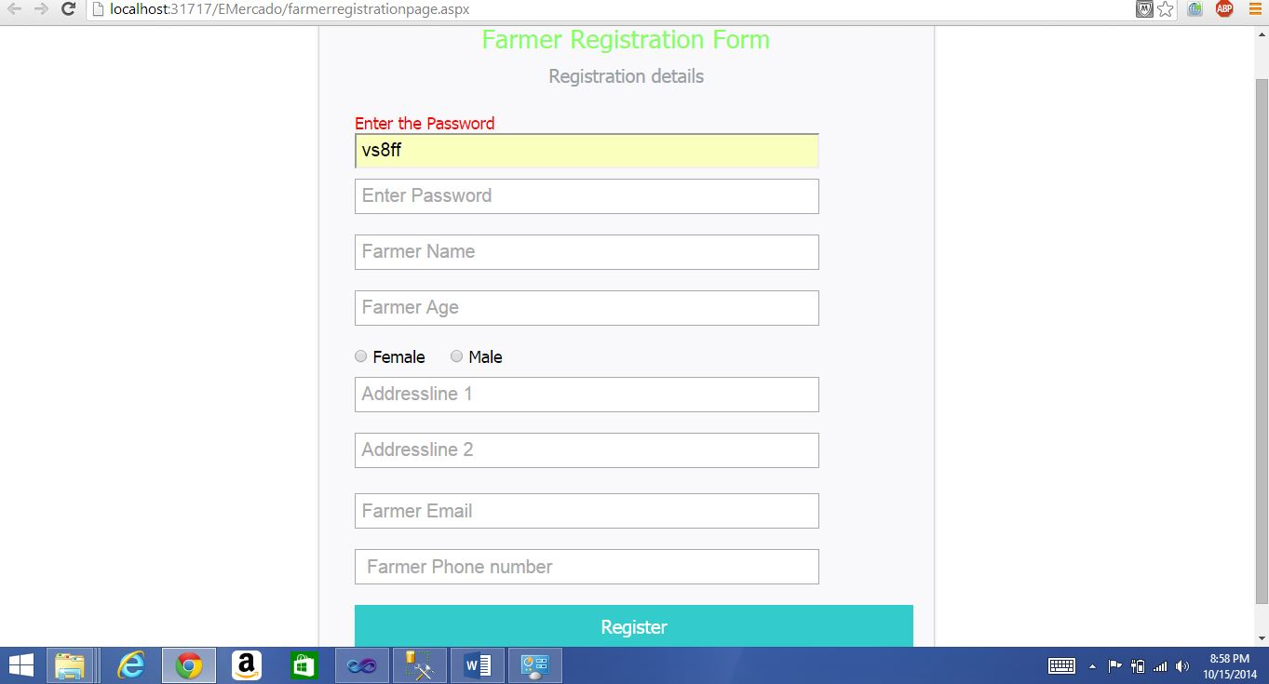

Farmer registration page validations 1

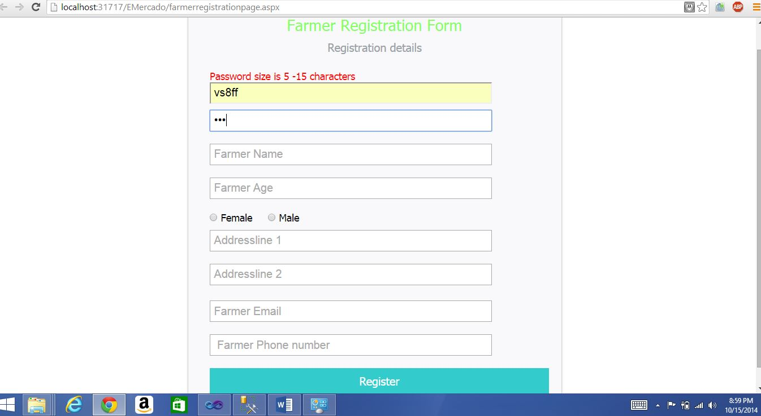

Farmer registration page validations 2

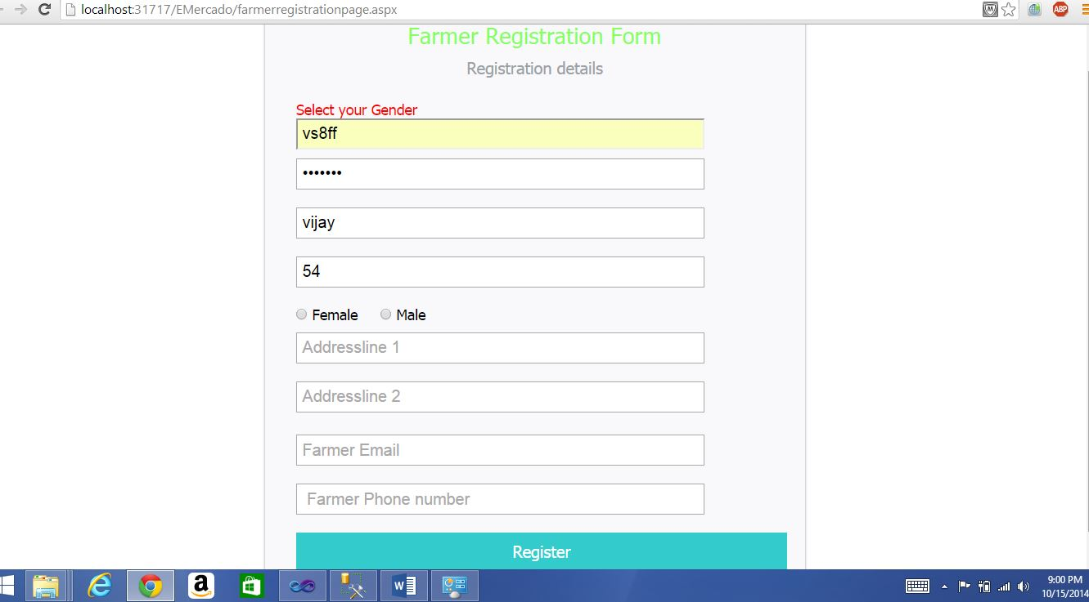

Farmer registration page validations 3

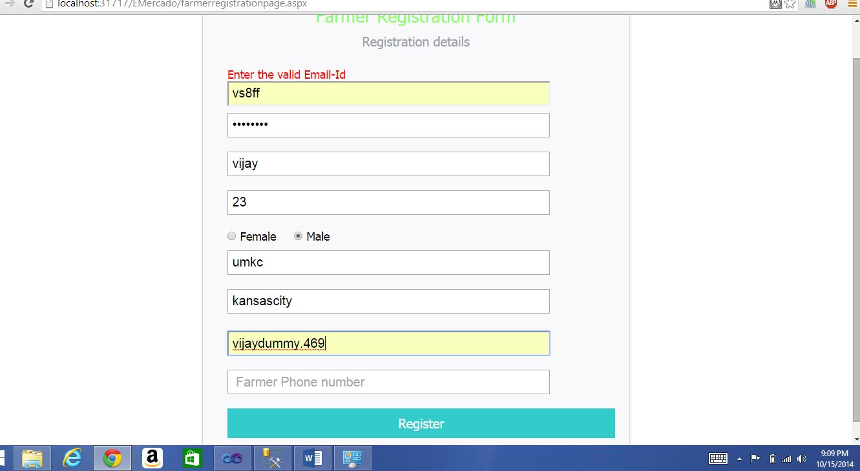

Farmer registration page validations 4

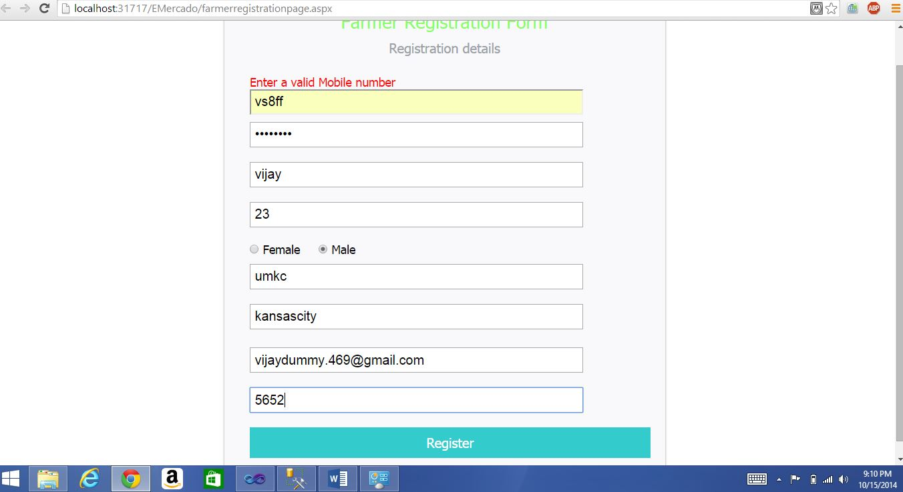

Farmer registration page validations 5

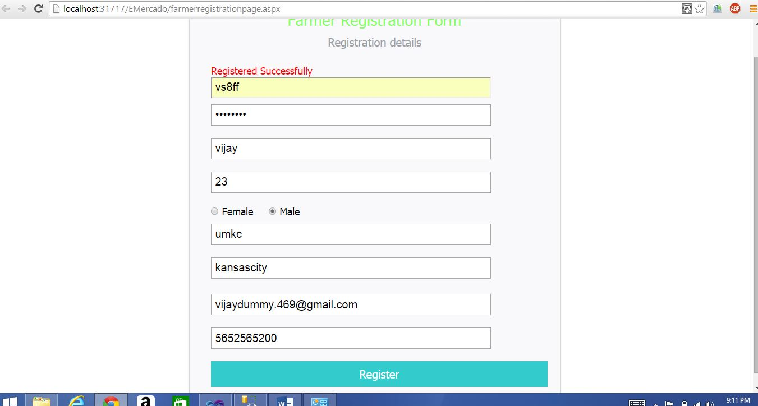

Farmer registration page validations 6

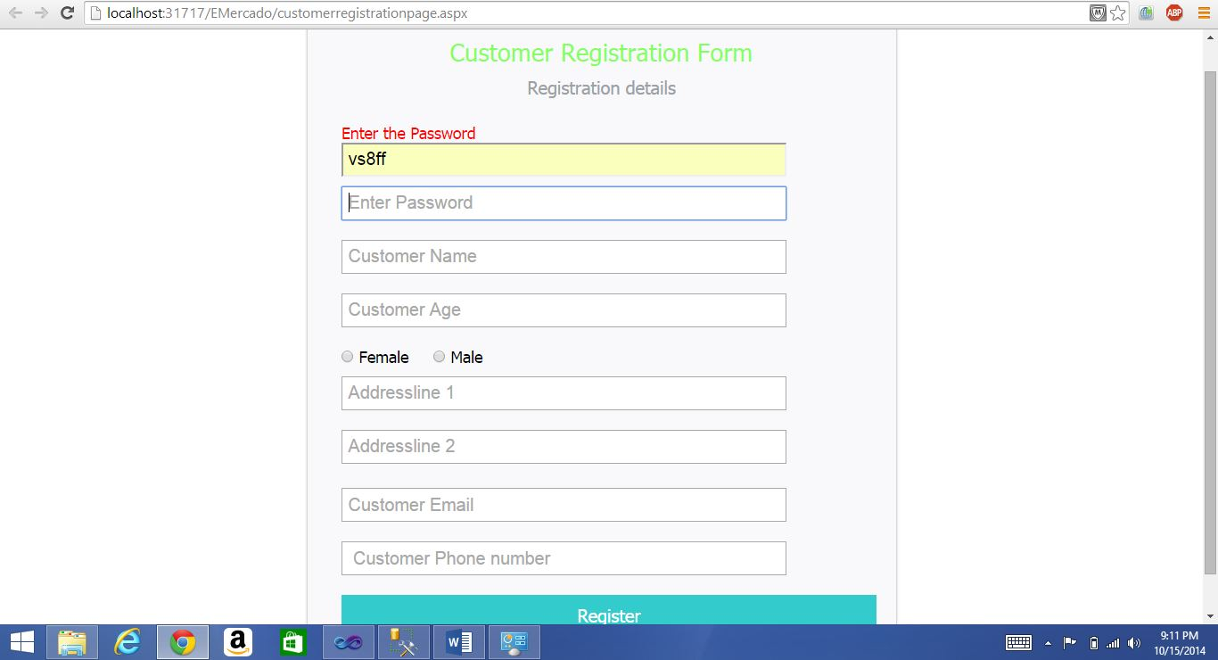

Customer registration page validations 1

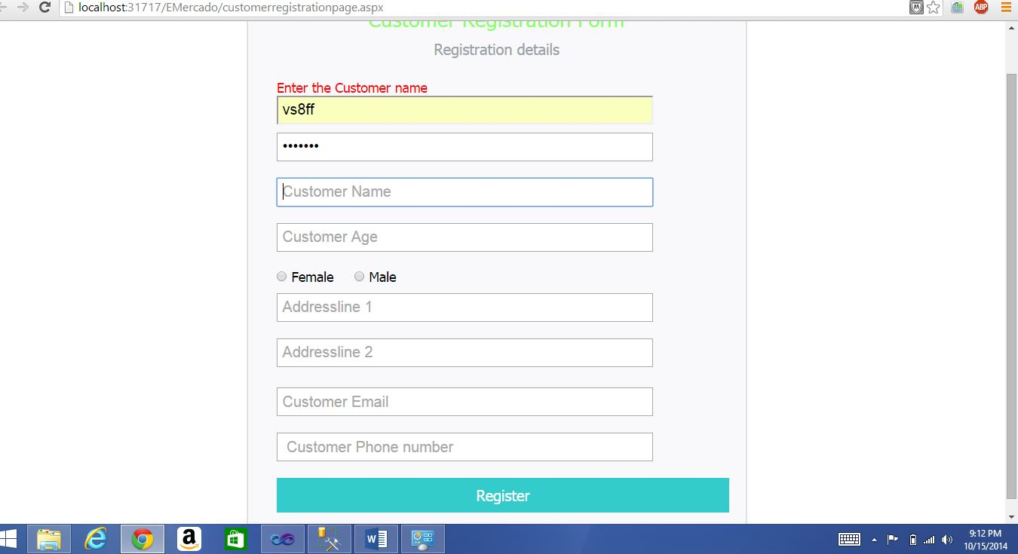

Customer registration page validations 2

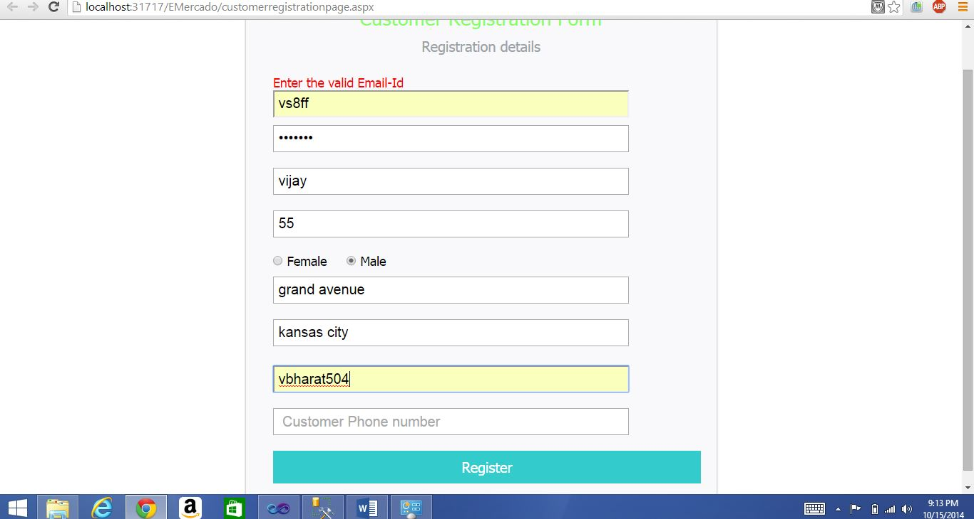

Customer registration page validations 3

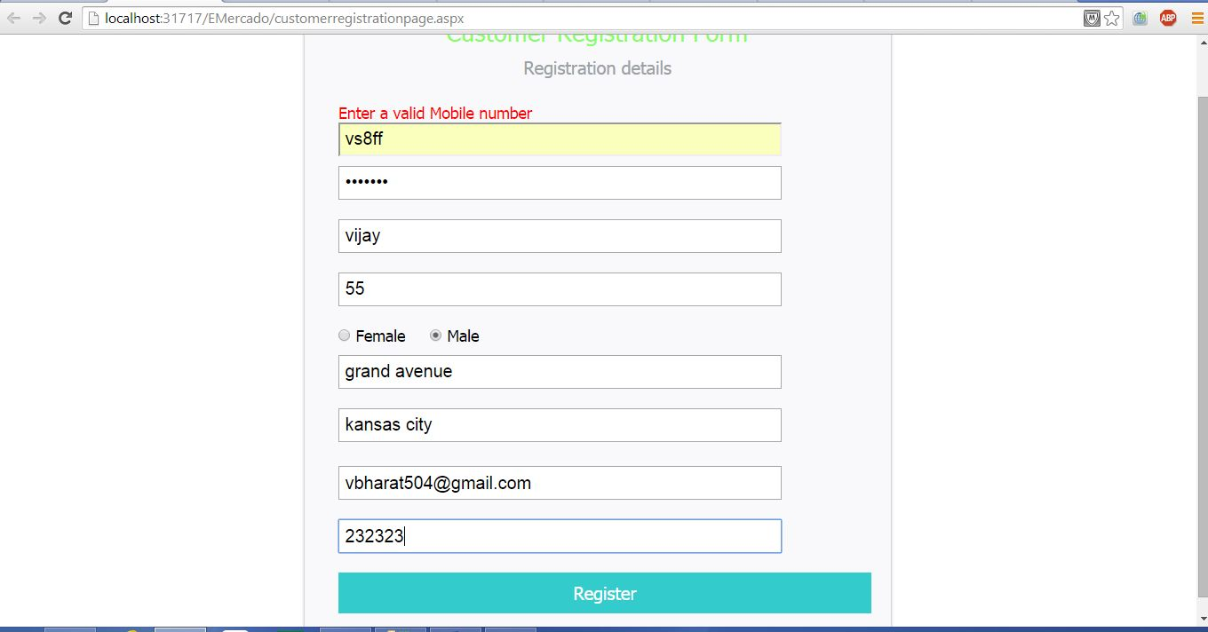

Customer registration page validations 4

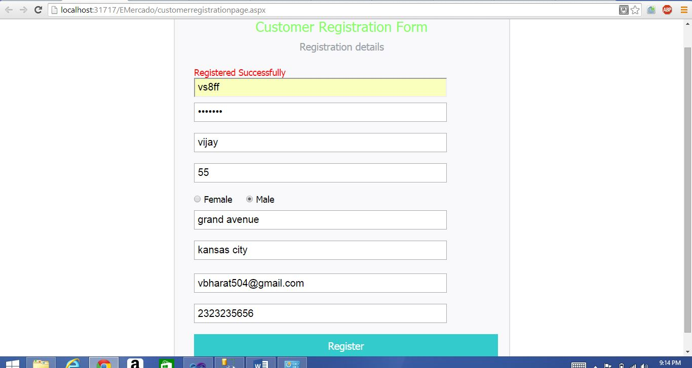

Customer registration page validations 5

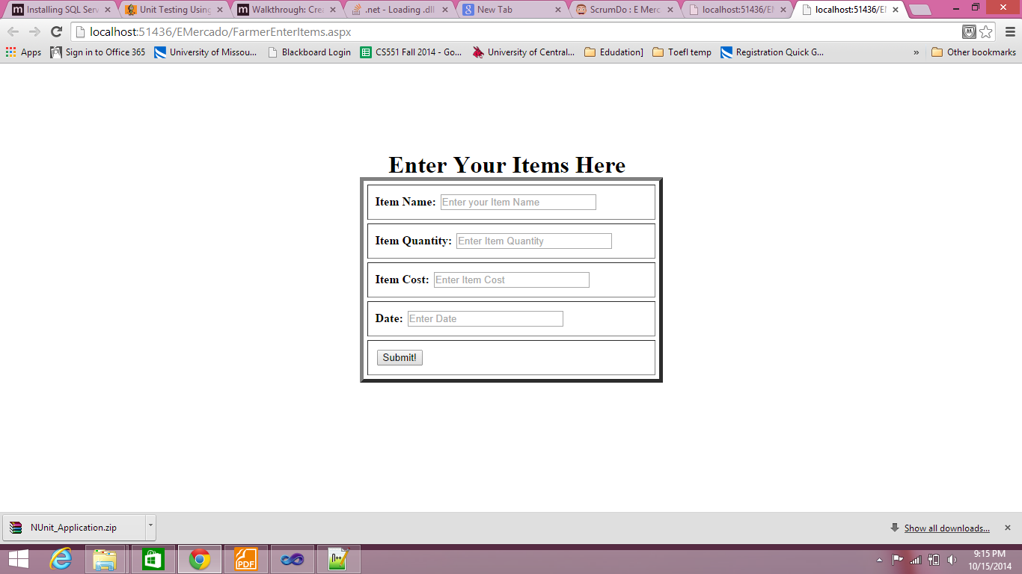

Farmer Enter Items page